# Siyuan Li, N16908535, sl6462

# Karl Gharbi,

# Reports

1. A screenshot of OpenFlow control messages you captured with WireShark.
2. Output of mininet “net” command for both topologies. (you can use any N for Fat-tree, ex: 4, 6, 8)

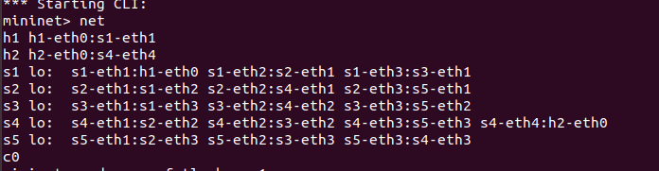

1. Mininet output while creating the networks

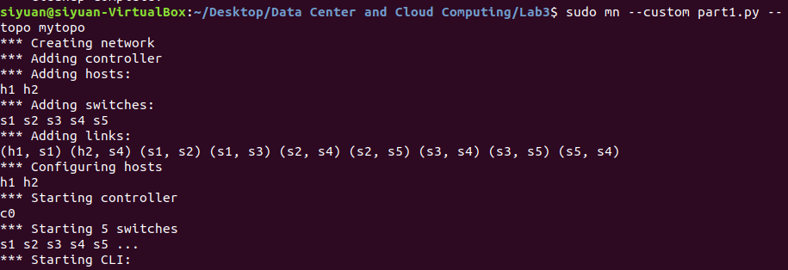

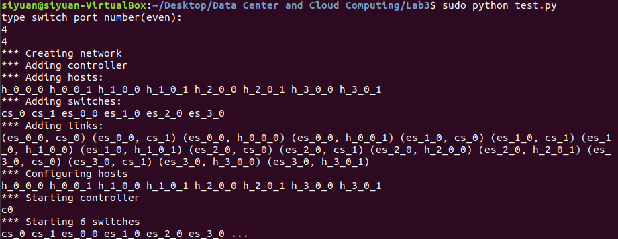

1. Briefly explain how you produce different traffic to verify whether the rules installed function correctly.
2. With the produced traffic, show the screenshots of Wireshark capture on different links (switch with interface) to verify the paths taken by different traffic are correct.
3. OVS-OFCTL commands used to install the rules on switches. (If you use a controller, upload your controller program)

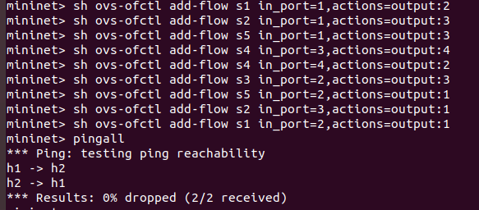

* 1. Traffic from H1 🡺 H2
     1. other traffic follows path: A-B-E-D
  2. Traffic from H2 🡺 H1
     1. other traffic, follow path: D-C-E-B-A

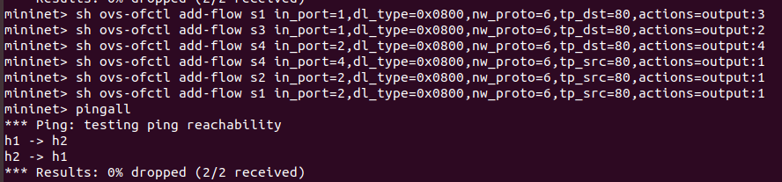

* 1. Traffic from H1 🡺 H2
     1. HTTP traffic with d_port=80 follows path: A-C-D
  2. Traffic from H2 🡺 H1
     1. HTTP traffic with s_port=80, follow path: D-B-A

1. Also submit all your python files used in this lab (do NOT paste code in report).